INTEGRATIVE COURSE IN PSYCHOLOGY (ICOPSYCH)

ANALYSIS ON THE RESULT OF PRE-BOARD EXAMINATION IN ABNORMAL PSYCHOLOGY
MARCH 8, 2025
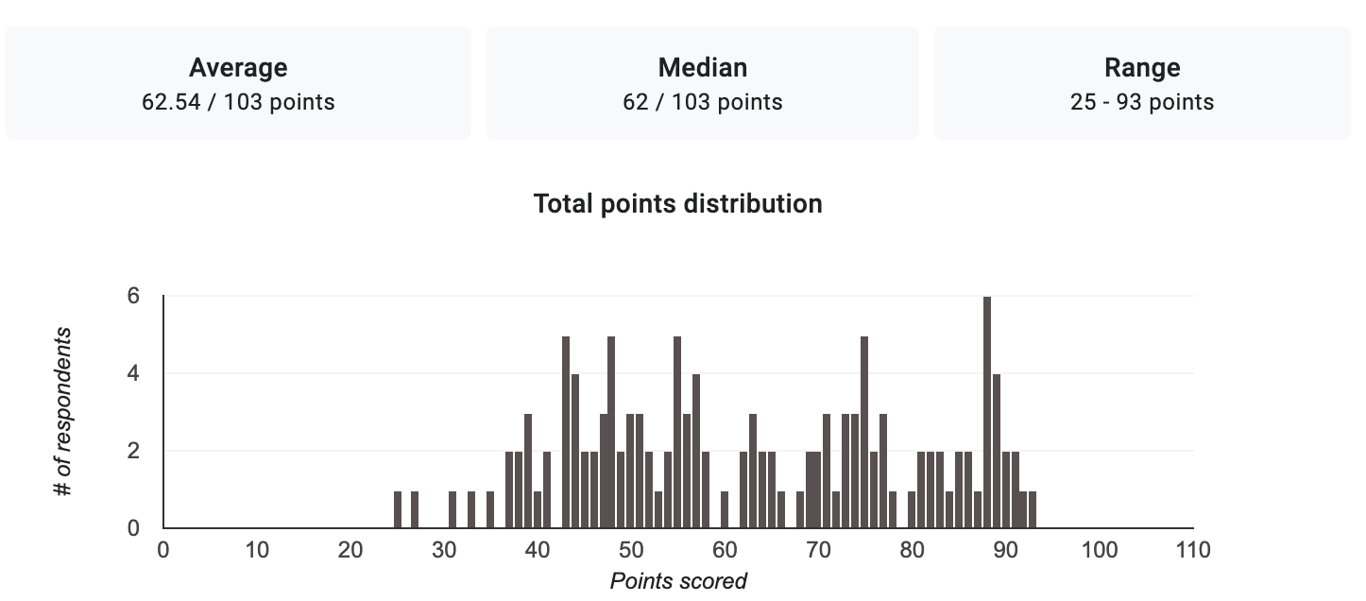

1. Mean Score: The mean (average) score of the exam is 62.54 out of 100. This suggests that, on average, students scored a little over 62.5, indicating a moderate level of understanding of the course.

2. Median Score: The median score is 62 out of 100. The median is the middle value when all scores are arranged in order. This indicates that half of the students scored below 62, and half scored above. Since the mean and median are relatively close, it suggests that the distribution of scores isn't heavily skewed.

3. Range: The range of scores is from 25 to 93 points. This means the lowest score was 25, while the highest score was 93. A wide range like this indicates some variability in student performance; while some students performed very well, others struggled significantly.

Interpretation Summary:

- The average and median scores suggest that the overall performance of students on this exam was moderate, with a slight tendency toward lower scores.

- The presence of a low score (25) indicates some students may have found the material challenging or may not have prepared adequately, while a high score (93) indicates that some students grasped the content very well.

- This variability may suggest different levels of understanding among students, possibly reflecting differences in study habits, preparation, or prior knowledge of the subject matter.

In conclusion, while some students performed well on the exam, the overall data indicates that many may need additional support or study techniques to improve their understanding of abnormal psychology.

RATIONALIZATION:

DIFFICULT QUESTIONS:
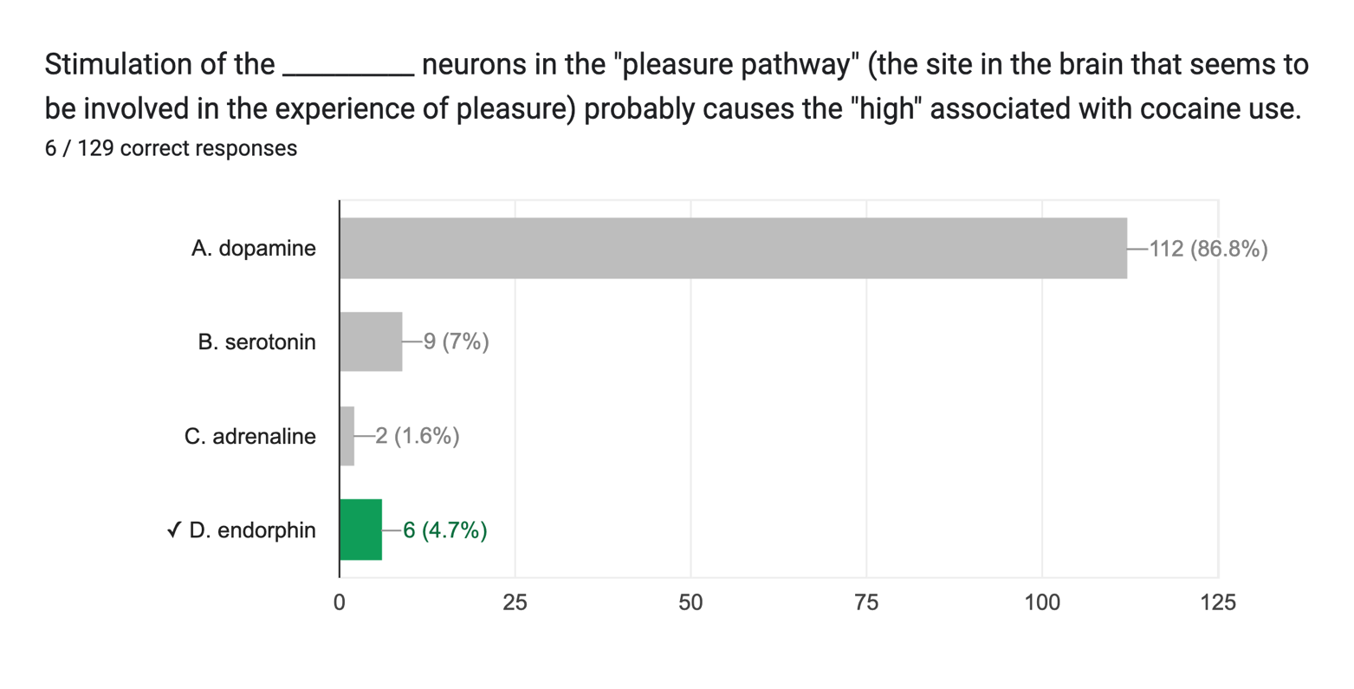

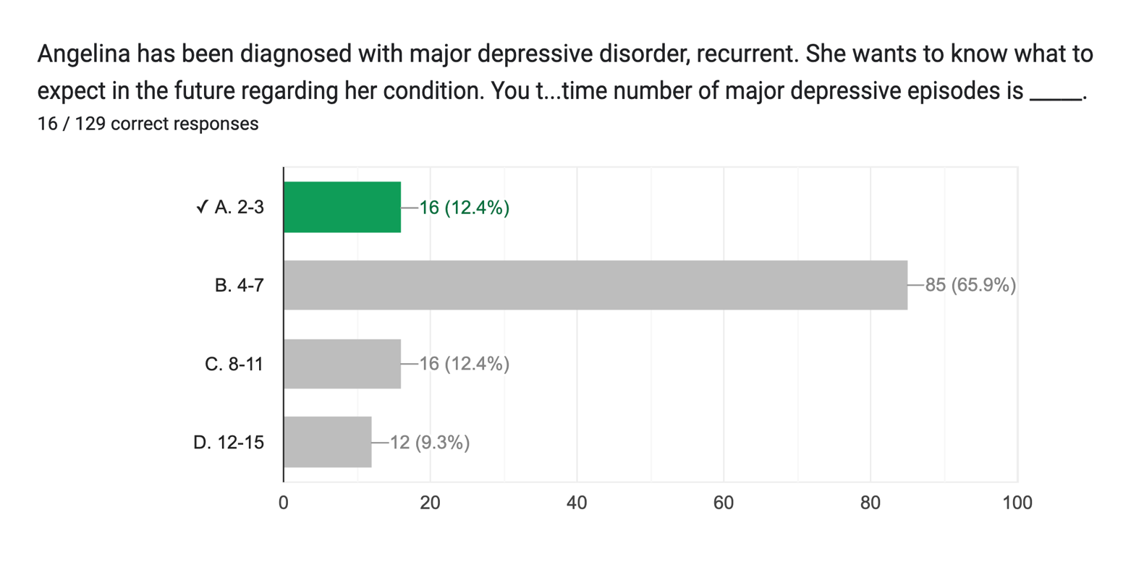

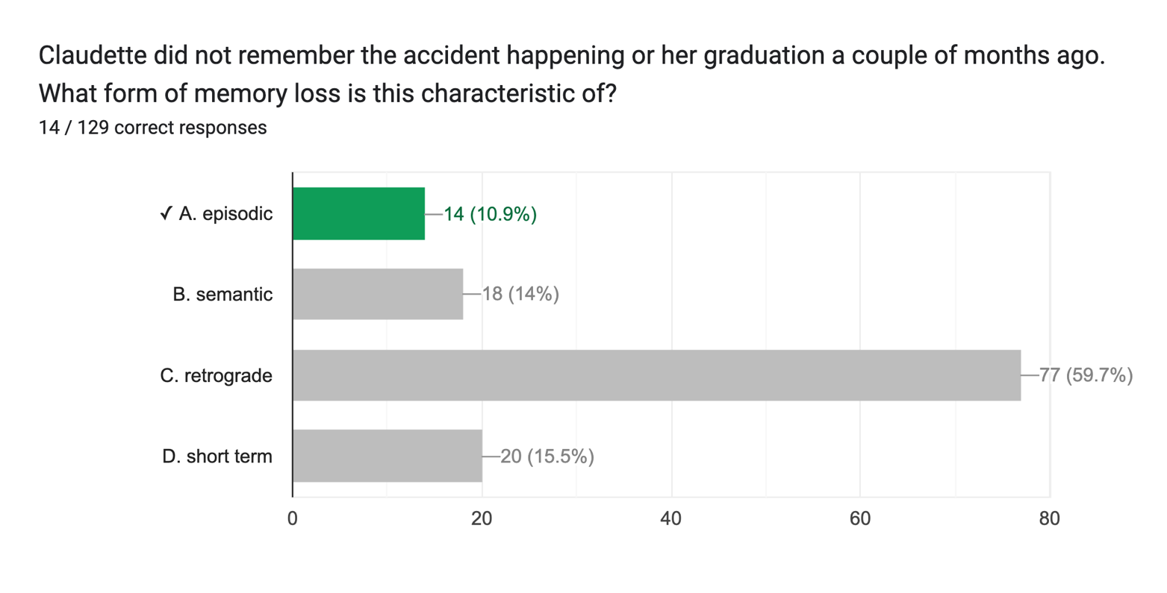

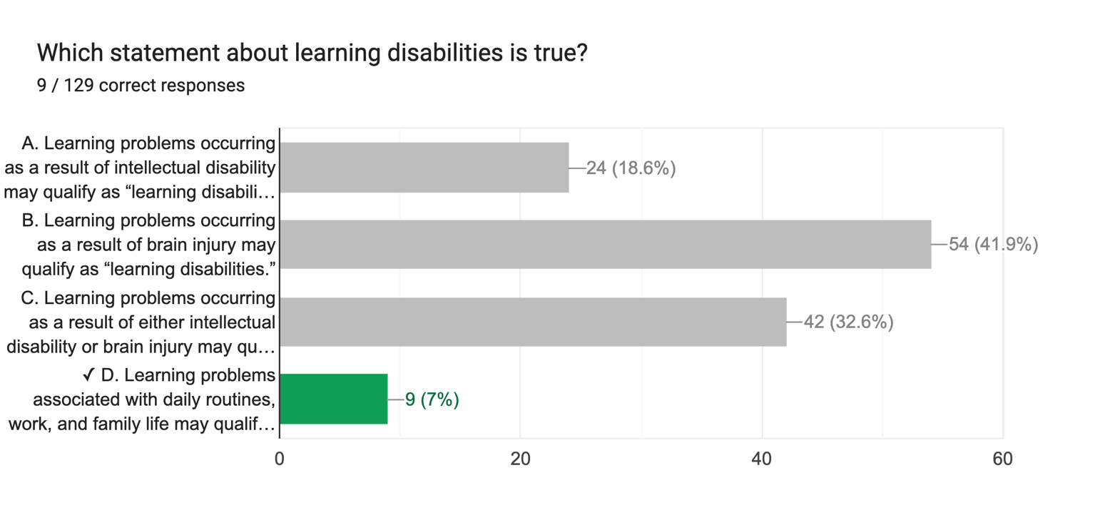

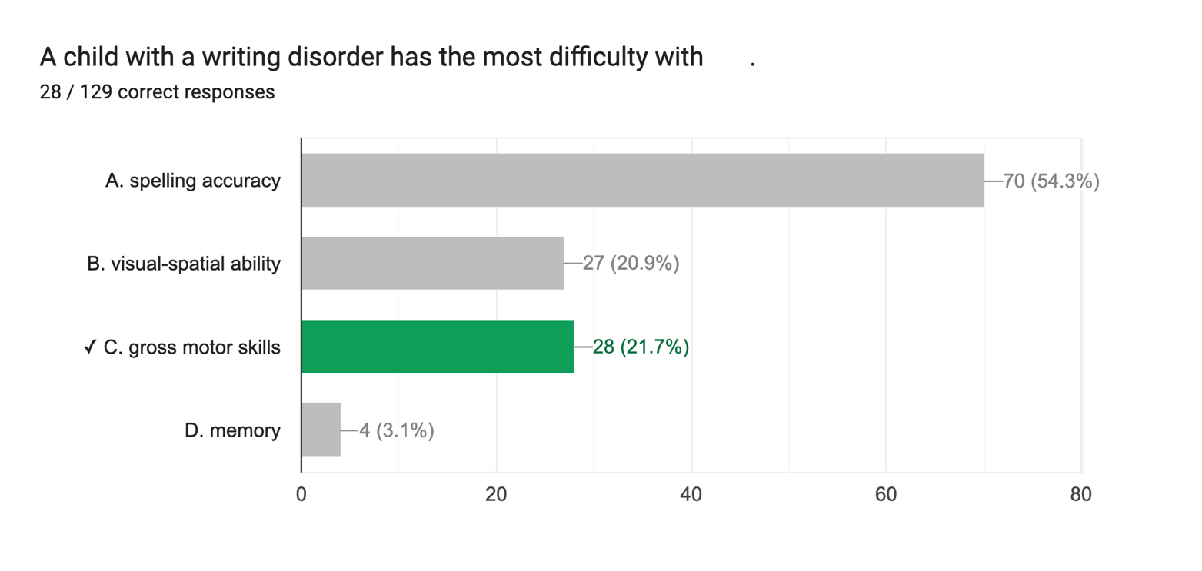

Based on the observations you've provided regarding the students' exam performance, several targeted interventions can be implemented to address the variability in understanding and to support both struggling and high-achieving students. Here are some suggestions:

1. **Differentiated Instruction:**
- Tailor instructional strategies to accommodate varying skill levels. This might include providing advanced materials or projects for high-achieving students while offering more foundational support or alternative resources for those who struggled.

2. **Targeted Review Sessions:**
- Organize optional review sessions or study workshops focused on challenging topics. These could be led by teachers or peer tutors and specifically designed to address areas where students performed poorly.

3. **Study Skills Workshops:**
- Offer workshops that teach effective study strategies, time management, and test-taking techniques. This can help students develop better preparation habits for future assessments.

4. **Formative Assessments:**
- Implement periodic low-stakes assessments (quizzes, reflections) to gauge students' understanding throughout the course. This can help identify students who are struggling sooner, allowing for timely intervention.

5. **Peer Tutoring Programs:**
- Establish a peer tutoring system where students who excel in certain areas can support those who are struggling. This encourages collaborative learning and can boost confidence among both groups.

6. **Individualized Learning Plans:**
- Create personalized learning plans for students who demonstrate significant gaps in understanding. This may involve setting specific goals, choosing appropriate resources, and scheduling regular check-ins.

7. **Feedback Mechanisms:**
- Provide constructive feedback on the exam results, highlighting strengths and areas for improvement. Encourage students to reflect on their performance and set improvement goals.

8. **Resource Availability:**
- Ensure that students have access to additional resources, such as textbooks, online materials, or supplementary readings, to strengthen their understanding of the subject matter.

9. **Parent/Guardian Engagement:**
- Communicate with parents or guardians about students' performance, including ways they can support their children at home with study habits or motivational support.

10. **Mental Health and Wellbeing Support:**
- Address any potential psychological barriers, such as anxiety or lack of motivation, by providing access to counseling services or developing a positive classroom environment that emphasizes growth and learning.

Implementing a combination of these interventions can help create a more inclusive and supportive learning environment, ultimately improving student performance and confidence in their academic abilities.

